How to create the Urinalysis App?

The app is created in the MIT app inventor platform. The apk and the .aia file is uploaded to the server. Details about how to modify or re-build the app is given below:

1. Go to MIT app inventor website and click on the **Create apps** tab



1. Sign in to the platform using your Google credentials
2. In the app inventor interface, go to **My projects** and click on **Import projects (.aia) from the computer.** Go to the file location and select the Urinalysis.aia from the directory.

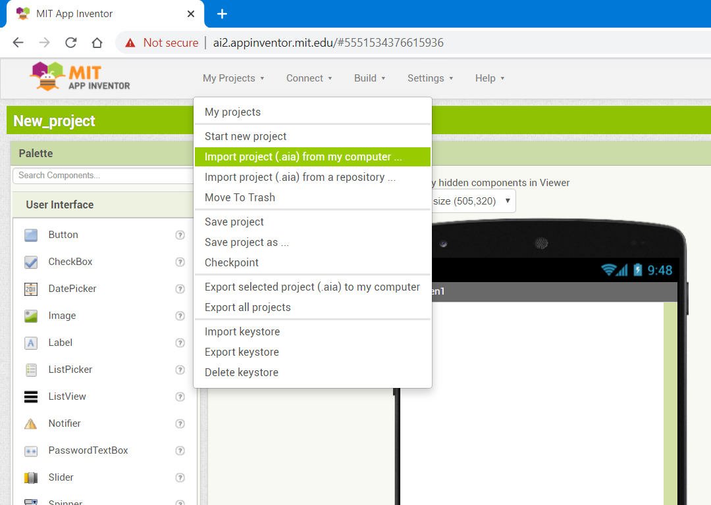

1. After importing the .aia file, the app inventor interface would look like below:

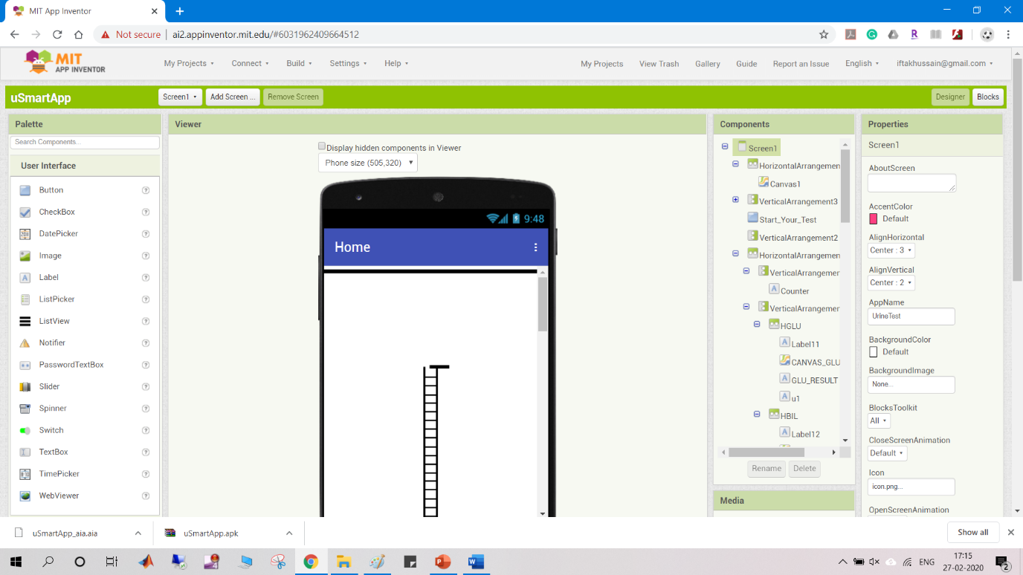

1. Go to blocks editor and starts coding for the app:

